Palindrome number

Exercise #1

Flutter Developer Boot-camp

# **Purpose**

This exercise demonstrate how to check if a given integer is a palindrome using Dart. A palindrome number is one that reads the same backward as forward, such as 121 or 54545. The code achieves this by reversing the digits of the input number and comparing the reversed number with the original number.

**Problem**

This exercise illustrates a simple Dart program designed to check whether a given integer is a palindrome. A palindrome number is one that reads the same forwards and backwards, like 121 or 54545. The code achieves this by reversing the digits of the input number and then comparing the reversed number to the original number. The process includes:

* Extracting digits from the original number.
* Building the reversed number.
* Comparing the reversed number to the original.
* Outputting whether the number is a palindrome or not.

**How to Solve**

1. Checkout the Exercise from Git Repo:

git clone -b <user-branch> <repo-URL>

2. Open the root folder inside VS Code

3. Open the root folder in terminal

4. Run the command dart run filename.dart

5. Reverses the digits: The loop extracts each digit from the end of the original number, builds the reversed number step by step, and reduces the original number by removing the last digit each time.

6. Compares: After reversing, it checks if the reversed number matches the original number.

7. Outputs Result: Prints whether the original number is a palindrome based on the comparison.

8. Go To File: <specific-file-with---method> à <method-name>, implement your logic.

**You will Achieve**

When you complete this exercise you will learn the following:

**Methods and Functions Included:**

* **Dart Functions:**
* void main(): The main entry point of the Dart program. This is where the program execution starts.
* **Control Structures:**
* while (number > 0): A loop that continues to execute as long as number is greater than 0.
* To reverse the digits of the number.
* if (sum == ABC): A conditional statement to check if the reversed number (sum) is equal to the original number (ABC).
* To determine if the number is a palindrome.
* else: The alternative path if the if condition is not met.
* To handle the case where the number is not a palindrome.
* **Arithmetic Operations:**
* reminder = number % 10: Modulus operation to get the last digit of the number.
* To extract the last digit from the number.
* sum = (sum * 10) + reminder: Multiplication and addition to build the reversed number.
* To construct the reversed number by shifting existing digits and adding the new digit.
* number = number ~/ 10: Integer division to remove the last digit from the number.
* To reduce the number by discarding its last digit.
* **Input/Output Operations:**
* print('Its A Palindrome number'): Outputs a message indicating the number is a palindrome.
* To inform the user of the result.
* print('Its A Not Palindrome number'): Outputs a message indicating the number is not a palindrome.
* To inform the user of the result.

# **Screenshots**

## **Expected output (Palindrome number)**

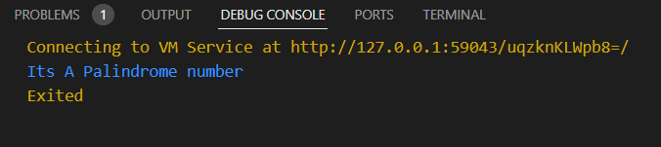

# **How to submit your exercise**

Push your project back to the same git branch using command:

<command name>

# **Happy Coding!**